# Navigation Bar

**THE BOLD FONTS ARE THE PAGES WITH THE SUBPAGE LISTED BELOW**

**Home About Dr. Manisha Homeopathy Services offered** - About Homeopathy - Homeopathy

- How it acts - Reiki

**Conditions treated Events Testimonies Gallery** (display all conditions in dropdown)- Videos

- Pictures

**Contact**

# Home

Home page should display

* Logo - Please create a logo for me Heal with Homeopathy (H will be shared with Heal and Homeopathy, below is a rough example). You can use your designers to come up with a better suggestion.
* About Dr Manisha - Please use the below photo, high res is provided in google drive.
* Testimonies - 3 testimonies on rotating basis - have selected the testimonies. Please check <http://freeingemotions.com/>, on the right side the testimonies are rotating.

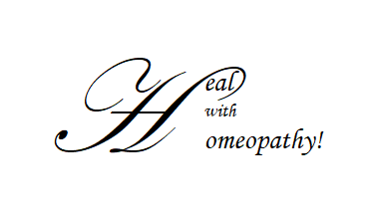

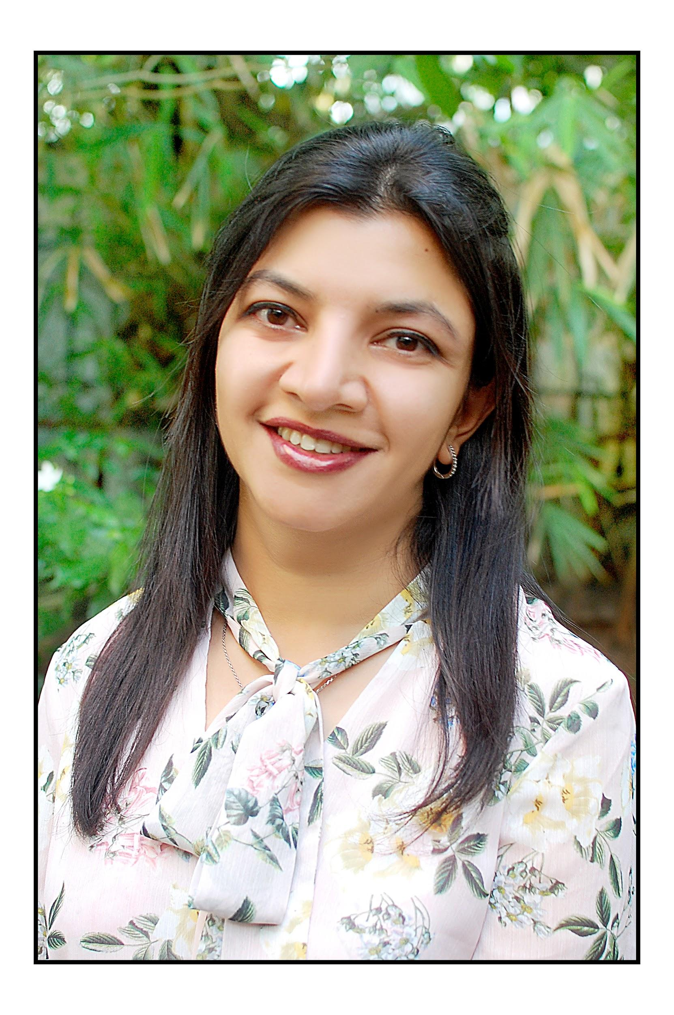

Just this photo on Homepage, confirm it is copyright free.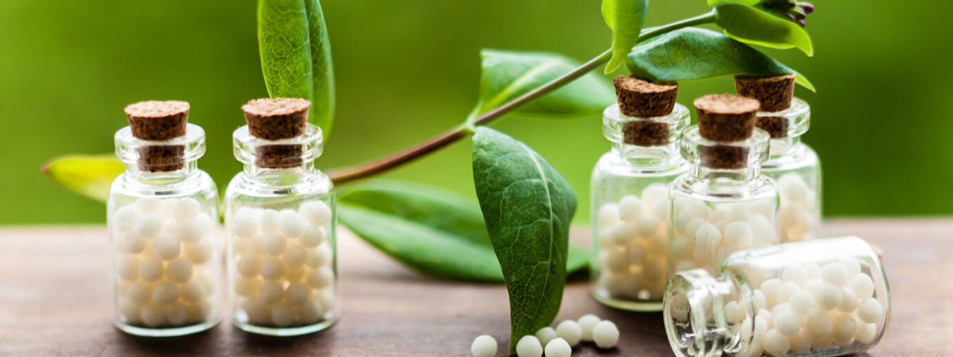

Please use a family photo, confirm it is copyright free

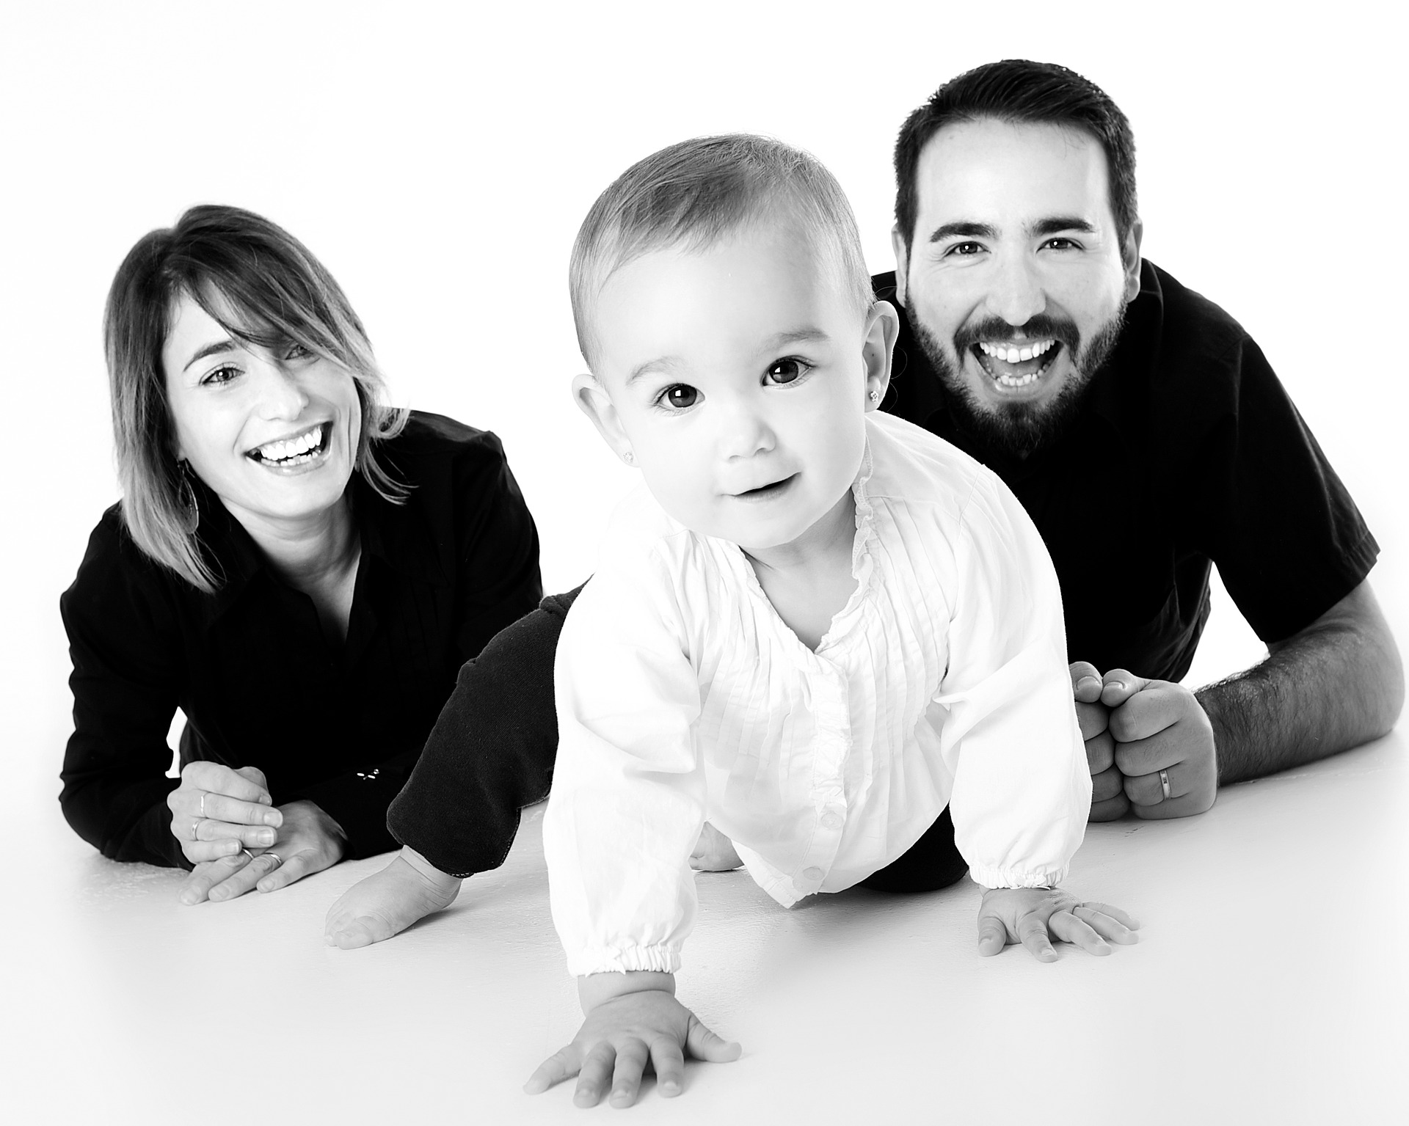

Homepage Layout

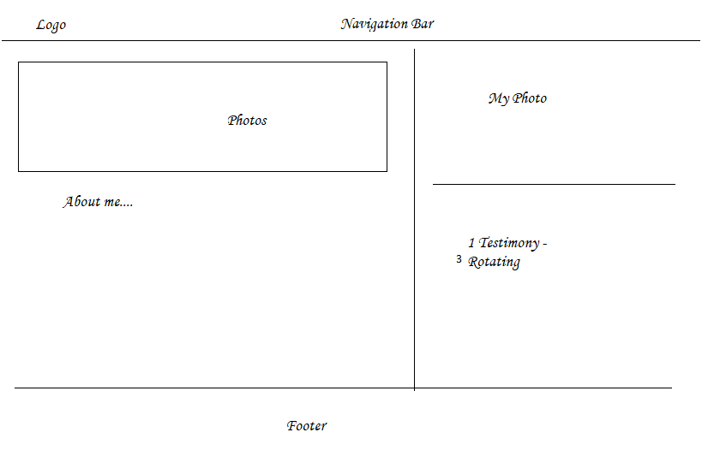

# About Dr. Manisha

Subtitle - About Dr. Manisha (The below information should be included in the the subtitle page About Dr Manisha)

## **Dr. Manisha Khiani – Homeopathic Doctor at IMI Hong Kong**

## **B.H.M.S.**

**Language:** English, Hindi

Dr. Manisha Khiani is a Homeopathic Doctor registered under Maharashtra Council of

Homeopathy in India.

She has particular expertise in acute and chronic conditions such as **asthma, allergies, stress-related disorders like anxiety, depression, insomnia, chronic fatigue syndrome, women’s health issues like menstrual disorders, fertility issues and PCOS, as well as common children’s health issues from viral fever to immunity boosting. She also treats skin issues like eczema and recurrent boils.**

**She is passionate to treat kids with asthma, and adults with anxiety and depression.**

“I am passionate to treat the whole family from babies to the elderly and dedicated to provide

each of my clients a natural, gentle, and effective health care solution in Homeopathy. I truly

believe that the bond of hope and faith between myself and my clients can lead us onto the path

of cure.”

Dr. Manisha completed her Bachelor of Homeopathic Medicine and Surgery degree from the

respected Maharashtra University of Health Sciences—a comprehensive five and-a- half year

program where she received extensive clinical training in both public and private hospitals.

Her five and half year training includes 4 years full time study of Medicine, Anatomy, Physiology and Pathology. One and half year of internship includes full time training in public as well as private hospitals.

Prior to moving to Hong Kong, Dr. Manisha had a successful career in India where she treated

more than 2,000 patients with a success rate over 90%. Her clients describe her as warm and

passionate in her approach to healing.

# Homeopathy

Subtitle - About Homeopathy (The below information should be included in the the subtitle page About Homeopathy )

## About Homeopathy

The word “Homeopathy” is derived from two Greek words: *homoios* which means “similar” and *pathos* which means “suffering.” Homeopathy’s basic premise is called the “principle of similars,” and it refers to recurrent observation and experience that a medicinal substance will elicit a healing response for the specific syndrome of symptoms (or suffering) that it has been proven to cause when given in overdose to a healthy person.

The beauty of the principle of similars is that it not only initiates a healing response, but it encourages a respect for the body’s wisdom. Because symptoms represent the best efforts of our body in its defenses against infection or stress, it makes sense to utilize a medicine that helps and mimics this defense rather than that inhibits or suppresses it. The principle of similars may be one of nature’s laws that, when used well, can be one of our most sophisticated healing strategies.

## **Making Homeopathic Medicines**

* Most homeopathic medicines are made by diluting a medicinal substance in a double-distilled water. It should be noted that physicists who study the properties of water commonly acknowledge that water has many mysterious and amazing properties. Because homeopaths use a double-distilled water, it is highly purified, enabling the medicinal substance to solely infiltrate and imprint the water. It is amazing how ill-informed and uninformed skeptics of homeopathy are on the physics of water.
* Each substance is diluted, most commonly, 1 part of the original medicinal agent to 9 or 99 parts double-distilled water. The mixture is then vigorously stirred or shaken. The solution is then diluted again 1:9 or 1:99 and vigorously shaken. This process of consecutive diluting and shaking or stirring is repeated 3, 6, 12, 30, 200, 1,000, or even 1,000,000 times. Simply “diluting” the medicines without vigorously shaking them doesn’t activate the medicinal effects.
* It is inaccurate to say that homeopathic medicines are extremely diluted; they are extremely “potentized.” “Potentization” refers to the specific process of sequential dilution with vigorous shaking. Each consecutive dilution infiltrates the new double-distilled water and imprints upon it the fractal form of the original substance used (fractal refers to the specific consecutively smaller pattern or form within a larger pattern). Ultimately, some type of fractal or hologram of the original substance may be imprinted in the water.

Over 200 years of experience by homeopaths throughout the world has shown that the more that a substance undergoes potentization (the process of sequential dilution with vigorous shaking in-between each dilution), the more powerful the medicine becomes, the longer it acts, and the less doses are generally needed. Because of these observations and experiences, homeopaths refer to medicines that have been potentized 200 times or more as “high potencies” and those that have been potentized less than 12 times as “low potencies.”

In this light, homeopaths insist that their medicines are NOT extremely small doses. Instead, they assume that the double-distilled and purified water is changed and becomes imprinted and activated.

Homeopaths will be the first to acknowledge that their medicine will not have any effect at all, unless the person taking them has a hypersensitivity to the medicine. A person will have this hypersensitivity if and when they exhibit the syndrome of symptoms that the substance has previously been found to cause.

## **How it acts**

Subtitle - How it acts (The below information should be included in the the subtitle page About How it acts)

How Homeopathy works:

The aspect of homeopathy that is implausible for many people is that the medicines are often – though by no means always – diluted to the point where there may be no molecules of original substance left. One of the leading current proposals for how such ‘ultramolecular’ dilutions work is that water is capable of storing information relating to substances with which it has previously been in contact.

**The structure of water**

Recent research on hydrogen bonds in water provides some support for this ‘memory’ theory. The Swiss chemist, Louis Rey, found that the structure of hydrogen bonds in homeopathic dilutions of salt solutions is very different from that in pure water. He reached the conclusion that the phenomenon results from the vigorous shaking of solutions that takes place during homeopathic ‘succussion’. Moreover, using the laboratory technique called spectroscopy, other researchers have found that different homeopathic medicines and different dilutions of the same medicine can be distinguished from each other, even though all should contain nothing but water.

Another Nobel Prize-winning scientist, emeritus professor of Cambridge University Dr Brian Josephson wrote this in response to an article about Homeopathy in *New Scientist*.

“Regarding your comments on claims made for homeopathy: criticisms centered around the vanishingly small number of solute molecules present in a solution after it has been repeatedly diluted are beside the point, since advocates of homeopathic remedies attribute their effects not to molecules present in the water, but to modifications of the water's structure.”

“Simple-minded analysis may suggest that water, being a fluid, cannot have a structure of the kind that such a picture would demand. But cases such as that of liquid crystals, which while flowing like an ordinary fluid can maintain an ordered structure over macroscopic distances, show the limitations of such ways of thinking. There have not, to the best of my knowledge, been any refutations of homeopathy that remain valid after this particular point is taken into accout.

For 200 years now, millions of physicians and hundreds of millions of homeopathic patients have observed and experienced the power and effectiveness of homeopathic medicines

**The Power of Nano-doses : By Dr Dana Ullman, foremost spokesperson for homeopathic medicine in U.S. explains how increased pressure and temperature changes structure of water.**

Precisely how homeopathic medicines work remains a mystery, and yet, nature is replete with mysteries and with numerous striking examples of the power of extremely small doses.

For instance, it is commonly known that a certain species of moth can smell pheromones of its own species up to two miles away. It is no simple coincidence that species only sense pheromones from those in the same species who emit them (akin to the homeopathic principle of similars), as though they have developed exquisite and specific receptor sites for what they need to propagate their species. Likewise, sharks are known to sense blood in the water at distances, and when one considers the volume of water in the ocean, it becomes obvious that sharks, like all living creatures, develop extreme hypersensitivity for whatever will help ensure their survival.

That living organisms have some truly remarkable sensitivities is no controversy. The challenging question that remains is: How does the medicine become imprinted into the water and how does the homeopathic process of dilution with succussion increase the medicine’s power? Although we do not know precisely the answer to this question, some new research may help point the way.

The newest and most intriguing way to explain how homeopathic medicines may work derives from some sophisticated modern technology. Scientists at several universities and hospitals in France and Belgium have discovered that the vigorous shaking of the water in glass bottles causes extremely small amounts of silica fragments or chips to fall into the water. Perhaps these silica chips may help to store the information in the water, with each medicine that is initially placed in the water creating its own pharmacological effect. In any case, each medicinal substance will interact with the silica fragments in its own idiosyncratic way, thereby changing the nature and structure of water accordingly.

Further, the micro-bubbles and the nano-bubbles that are caused by the shaking may burst and thereby produce microenvironments of higher temperature and pressure. Several studies by chemists and physicists have revealed increased release of heat from water in which homeopathic medicines are prepared, even when the repeated process of dilutions should suggest that there are no molecules remaining of the original medicinal substance

Also, a group of highly respected scientists have confirmed that the vigorous shaking involved with making homeopathic medicines changes the pressure in the water, akin to water being at 10,000 feet in altitude (Roy, et al., 2005). These scientists have shown how the homeopathic process of using double-distilled water and then diluting and shaking the medicine in a sequential fashion changes the structure of water.

It is important to understand that nanopharmacological doses will not have any effect unless the person is hypersensitive to the specific medicinal substance. Hypersensitivity is created when there is some type of resonance between the medicine and the person. Because the system of homeopathy bases its selection of the medicine on its ability to cause in overdose the similar symptoms that the sick person is experiencing, homeopathy’s principle of similars is simply a practical method of finding the substance to which a person is hypersensitive.

# Services offered

## Homeopathy

Still need to add content

## 

## Reiki

Subtitle - Reiki (The below information should be included in the the subtitle page Reiki )

Dr Manisha also practices Reiki in IMI. She is Reiki certified Healer from India and is known for her intuitive awareness about her clients. She is compassionate which makes her an powerful empathic healer. “Reiki has empowered my life. It has healed my emotions and has given me a vision of my life.”, says Dr. Manisha.

# 

# Conditions Treated

Asthma

Anxiety & Depression

ADD / ADHD

Allergies

Constipation & Digestive disorder

Colds, flu & ear infections

Diabetes type II

Eczema / Skin Rash

Endometriosis

Fibromyalgia / Chronic Fatigue

Hormonal Issues in Women

Headaches / Migraines

IBS (Irritable Bowel Syndrome)

Insomnia

Menstrual Issues

Thyroid Disorders

Women’s Health issues

# Events

Still need to add content

# Testimonies

Please take font and design ideas from this webpage <http://freeingemotions.com/testimonials>

“Dr. Manisha has helped us with our son, who had fever around 39.4 and congestion in chest

lasting from 2 days. She was kind and patient and thorough with her skills. I felt at ease when

she inquired about my child’s health several times on Whatsapp, too. I highly recommend her

for homeopathic treatment, specially with kids because she is really skillful doctor.”

-- Miss Wong

Please use the following testimony (V) on rotating basis for home page

“Dr. Manisha has really done a fantastic job to help our 3 year old son who was suffering from

fever lasting for 5 days. Not only did she find the right remedy immediately through a very

thorough consultation, which isn’t the standard in Hong Kong’s rushed environment. She also

showed a lot of personal care by checking on his recovery several times—even on the

weekend! We felt in really good hands and we will definitely recommend her to our friends.

-- V

“I had a recurrent migraine at my lower head and the pain had lasted for months. I was tired of

treating the pain by Panadol so I sought help from Dr. Manisha. She was so kind and patient to

consult me for 90 minutes, asking for my detailed health and personal backgrounds in order to

find the best and unique remedy for me. After taking a single dose, I felt the pain reduced

gradually. I really appreciate Dr. Manisha for her treatment as this pain had really been a

nightmare for me.”

-- E. Wong

“I was having an on-and- off cough, a very sore throat with white spots on my tonsils for 2

months. Dr. Manisha prescribed me these amazing homeopathic pills to be taken once a day for

7 days and I got amazing results. My cough got better and throat pain was gone after only 1

day. I felt energetic and active again and was back to work with full enthusiasm. I missed my

work a lot because of recurrent infection in past. I highly recommend her because she

prescribes accurate medicine with fewer doses.”

-- Jing

“I came to see Dr. Manisha for my 16 months old son who had a fever and had been coughing

for a couple of days. Within 12 hours the temperature was gone and after 3 days the cough as

well. Homeopathy for baby and kids are working very well. Dr. Manisha is very understanding. I

appreciate a lot that she follows up the recovery of my son via Whatsapp. I highly recommend

her.”

-- F

Please use the following testimony (Rebecca) on rotating basis for home page

“I have experienced great improvement and rejuvenation of the soul whilst on the homeopathic

remedy treatments. My entire being has increased in confidence and I feel that I can face the

day with a smile and positive thoughts. In the beginning of my interactions with Dr. Manisha, I

felt very anxious and stressed due to the hard pressures of the Hong Kong educational system.

Over the course of the two months I have spent with her, I have learned to look within myself

and slowly bring harmony to my body that has helped to increase the overall calm of my

exterior. I can finally sleep again! I am eternally grateful to Dr. Manisha! She has been a joy and

pleasure for our family as well.”

-- Rebecca, 16 years old at the time of treatment.

Please use the following testimony (Aastha) on rotating basis for home page

“I came to see Dr. Manisha 3 months ago and was in complete despair. I had very heavy

menses and irregular in nature due to multiple fibroids in my uterus. I had lots of joint pain with a

history of fever, too.

Dr. Manisha took a detailed history of mine and gave me medicine that fits my constitution.

Within span of just few days my body ache and joint pain became better and my cycle became

regular. I did have good flow of menses which was not heavy for these last 2 cycles. I continued

to visit her and now my periods are regular with normal flow.

I appreciate Dr. Manisha for her help, she is a very compassionate and detailed person. She is

really thorough and excellent in her prescription. I highly recommend her to all my friends and

family.”

-- Miss Aastha

# Gallery

## Photos

Please use 10 photos - 5 before and after photos to add on the website

<https://drive.google.com/drive/folders/1n2E32b0xoQ6T3Se3E-lv7uLS87O2Lmzk>

## Videos

Still need to add content

# 

# Contact

Follow format <http://freeingemotions.com/contact>

Contact Dr. Manisha Khiani

Address: Integrated Medicine Institute | 13/F & 17/F Kailey Tower, 16 Stanley Street, Central, Hong Kong

Phone: (852) 2523-7121

Email: [drmanishakhiani@gmail.com](mailto:drmanishakhiani@gmail.com)

I’m available at [IMI](https://www.imi.com.hk/homeopathic-doctor-hong-kong.html) in Central, Hong Kong.

Contact Form

Name (required)

Email (required)

Subject

I am contacting you regarding : Reiki Homeopathy (radio button)

Message

(also use the similar protection to avoid spam)

Contact form should send an email to me [drmanishakhiani@gmail.com](mailto:drmanishakhiani@gmail.com)

Please add google maps, pointing to the above mentioned address.